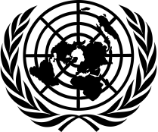
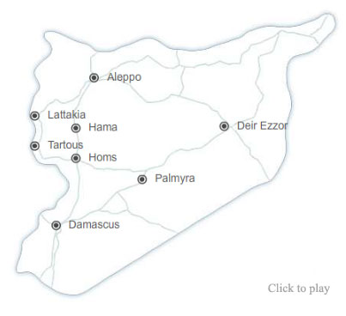
Syrian Crisis
United Nations Response

A Weekly Update from the
UN Department of Public Information No. 75/31 December 2014

Office of Special Envoy says it will attend Moscow conference
In response to a media question on the intra-Syrian negotiations scheduled to take place in Moscow, the Office of Special Envoy Staffan de Mistura said that it will be present at these talks. In a statement issued on 30 December, the Office of the Special Envoy said it welcomes any initiative that would push forward reaching a peaceful and diplomatic end to the crisis in Syria.
http://www.un.org/sg/spokesperson/highlights/index.asp?HighD=12/30/2014&d_month=12&d_year=2014

Escalation in fighting disrupts aid delivery in Yarmouk refugee camp
The UN Relief and Works Agency for Palestine Refugees (UNRWA) said on 30 December that a serious escalation in armed conflict in Yarmouk and its surroundings over the past two weeks has repeatedly disrupted the agency’s food delivery operations. “Approximately 400 food parcels are required each day to meet the minimum food needs of this extremely vulnerable population, and UNRWA remains deeply concerned that fewer than 700 parcels have been distributed over the course of the entire month of December. This underlines the extremely worrying fact that for the civilian population of Yarmouk, food, health care, and other essential, minimum human requirements remain substantially unmet, said UNRWA Spokesperson Chris Gunness. UNRWA reiterates its appeal for an immediate cessation of armed hostilities inside Yarmouk and for recourse to negotiations to maintain calm inside Yarmouk and its surrounding areas.
http://www.unrwa.org/crisis-in-yarmouk

36 Mayors participate in UNDP workshop on building resilience in Jordan
The UN Development Programme (UNDP), in partnership with experts from the Sub-Regional Facility on the Syrian Response, and the Jordanian Ministries of Municipal Affairs and Interior, organized a two-day workshop on 26-27 December, which was attended by 36 Mayors from Irbid and Mafraq Governorates. During the retreat, many meetings were held to introduce interventions of UNDP in local communities, such as vocational training, microbusinesses, municipal support and community outreach activities. Discussions included situation analysis on the current responses of the Municipalities affected by the Syrian refugee crisis. Among key challenges, mayors cited inadequate public services, lack of jobs, rising social tensions and security concerns. The meeting addressed these challenges, and concluded that municipalities need to optimize their resources.
http://www.jo.undp.org/content/jordan/en/home/presscenter/pressreleases/2014/12/26/36-mayors-from-irbid-and-mafraq-governorates-participated-in-two-day-workshop-retreat-to-address-local-problems-and-build-resilience-/

WHO renovates psychiatric facilities in Damascus and Aleppo
The World Health Organization (WHO) launched on 28 December a renovation project of four psychiatric units in Damascus and Aleppo. These facilities will provide mental health services to more than 11,000 patients per year. According to the World Mental Health Survey 2000, the percentage of mentally affected people during crises is estimated at about 3%-4%. In Syria, it is estimated that approximately 600,000 people might be suffering from severe mental disorders; another 20% (i.e. approximately 4 million people) may be suffering from mild to moderate mental disorders, while 20%-40% might be experiencing mild psychological distress.
http://www.emro.who.int/syr/syria-news/psychiatric-facilities-renovated.html

UN Twitter

More than half a million women affected by the #SyriaCrisis are pregnant & need help, says @BabatundeUNFPA: http://j.mp/1vD4k5z
- 30 Dec 2014

In 2014, @WHO delivered over 13.5m medical treatments to people in need across war-torn Syria http://goo.gl/uaTKvW
- 29 Dec 2014

2014 was a busy year for the UN, from Syria & Ukraine to #EbolaResponse & #SouthSudan. Here's a recap. Watch: http://bit.ly/1CqWFyO
- 28 Dec 2014

UN Facebook

From Ebola-affected countries in Africa to Syria and Iraq, this year food assistance helped families get through emergencies.
Meet 10 people in 10 different countries who received assistance in 2014 thanks to World Food Programme's supporters: http://j.mp/1HWG9VG
- 30 Dec 2014

2014 was a busy year for the UN, from Syria and Ukraine to responding to the Ebola outbreak and the ongoing crisis in South Sudan.
Watch this video recap.
https://www.youtube.com/watch?list=PLwoDFQJEq_0aLhfFUoiHJshray_b4-ODe&v=MPX7HijnbmY
- 29 Dec 2014

Relevant links to UN Secretariat, Agencies, Funds and Programmes on Syria

DPI Focus Page on Syria:
http://www.un.org/apps/news/infocusRel.asp?infocusID=146&Body=Syria&Body1=

UN humanitarian agencies :
UNICEF: http://www.unicef.org/media/index.html
WFP: http://www.wfp.org/countries/syria
OCHA: http://www.unocha.org/crisis/syria
WHO: http://www.who.int/countries/syr/en/
UNHCR: http://www.unhcr.org/pages/4f86c2426.html
OHCHR: http://www.ohchr.org/en/NewsEvents/Pages/NewsSearch.aspx?CID=SY
UNRWA: http://www.unrwa.org/

UN on social media:
Twitter: https://twitter.com/UN
Flickr: http://www.flickr.com/photos/un_photo/
YouTube: http://www.youtube.com/unitednations
Tumblr: http://united-nations.tumblr.com/

Photo galleries:
UNHCR: http://www.unhcr.org/pages/49c3646c25d.html
UNRWA: http://www.unrwa.org/photogallery.php
OCHA: http://www.unocha.org/media-resources/photo-gallery
UNICEF: http://www.unicef.org/photography/photo_2013.php#UNI82253
IRIN: http://www.irinnews.org/photo/

